**Database Management System**

**(Lab Task No 02)**



Session (2022-2026)

Program/Class

**BS-Computer Science / 5rd Section-A**

Submitted By:

Student Name: Shaheer Ali Roll Number: 301-221044

Supervised By:

Ms. Muneeba Darwaish

Lecturer

CS& IT Department

**Hazara University, Mansehra**

**Part 1:**

Create a database named on your school (MAPS), show it, drop it, and show again that it is deleted (wohi kaam jo abhi kia using the 4 steps and also using the shortcut)

**Answer:**

**Step 1:**

First of all I have created a database named, Hazara University.

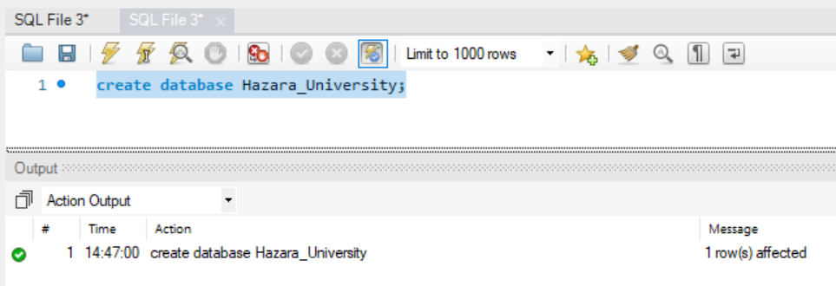

**Step 2:**

Then showed it using the show query,

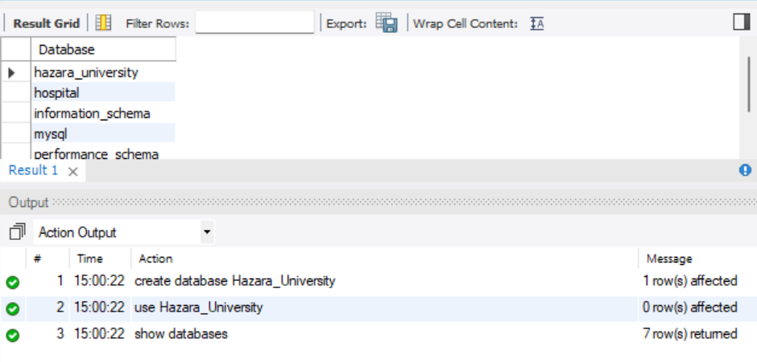

**Step 3:**

Then as per demand in the task, I dropped the database I created.

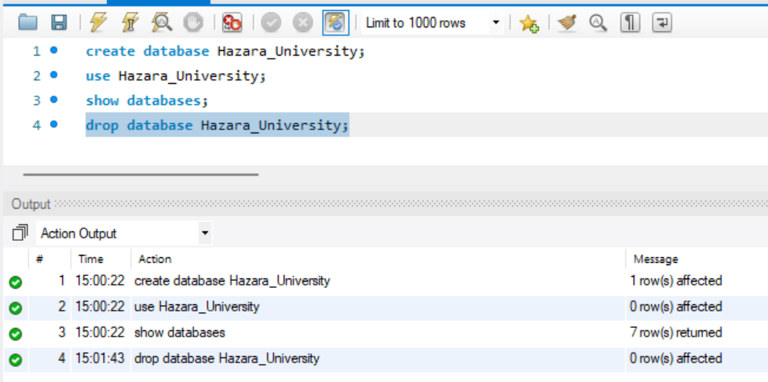

**Step 4:**

Showing Databases after dropping the database

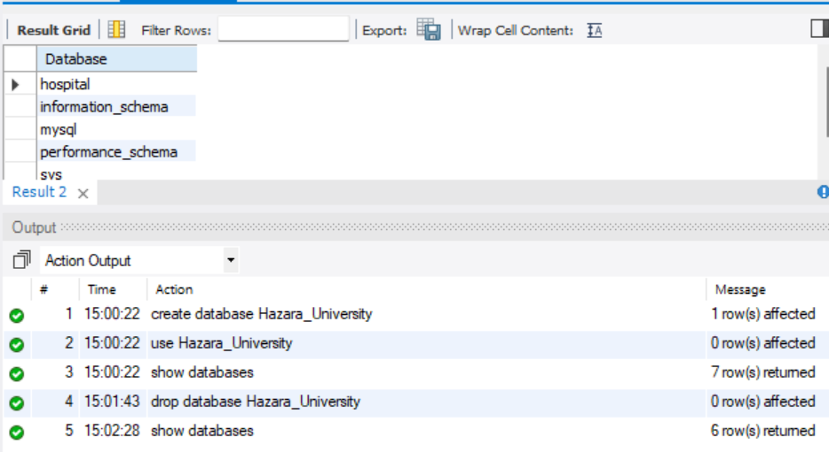

**Using Shortcut Method Discussed in Class:**

**Step 1:**

First I have clicked on the schemas on the left side of the tab, there are different databases showed, now I wll right click on the portion, there will be an option named create schema

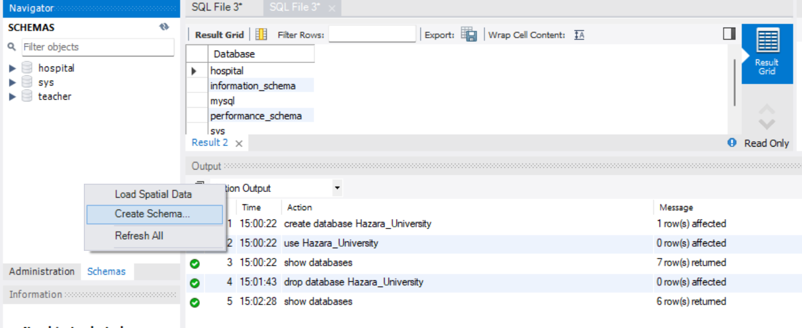

**Step 2:**

After clicking on create schema there it requires name for the database, I entered the name and then clicked on apply,

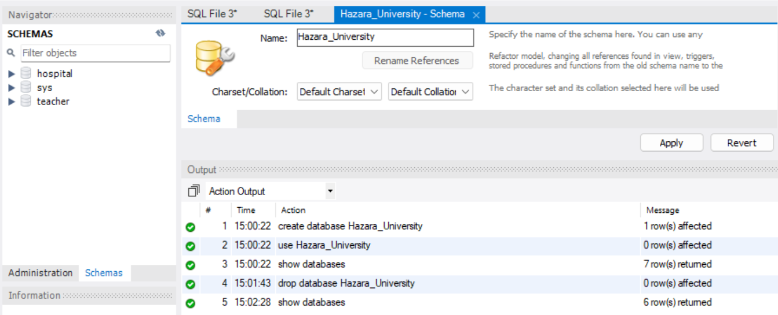

**Step 3:**

After that I proceeded to next,

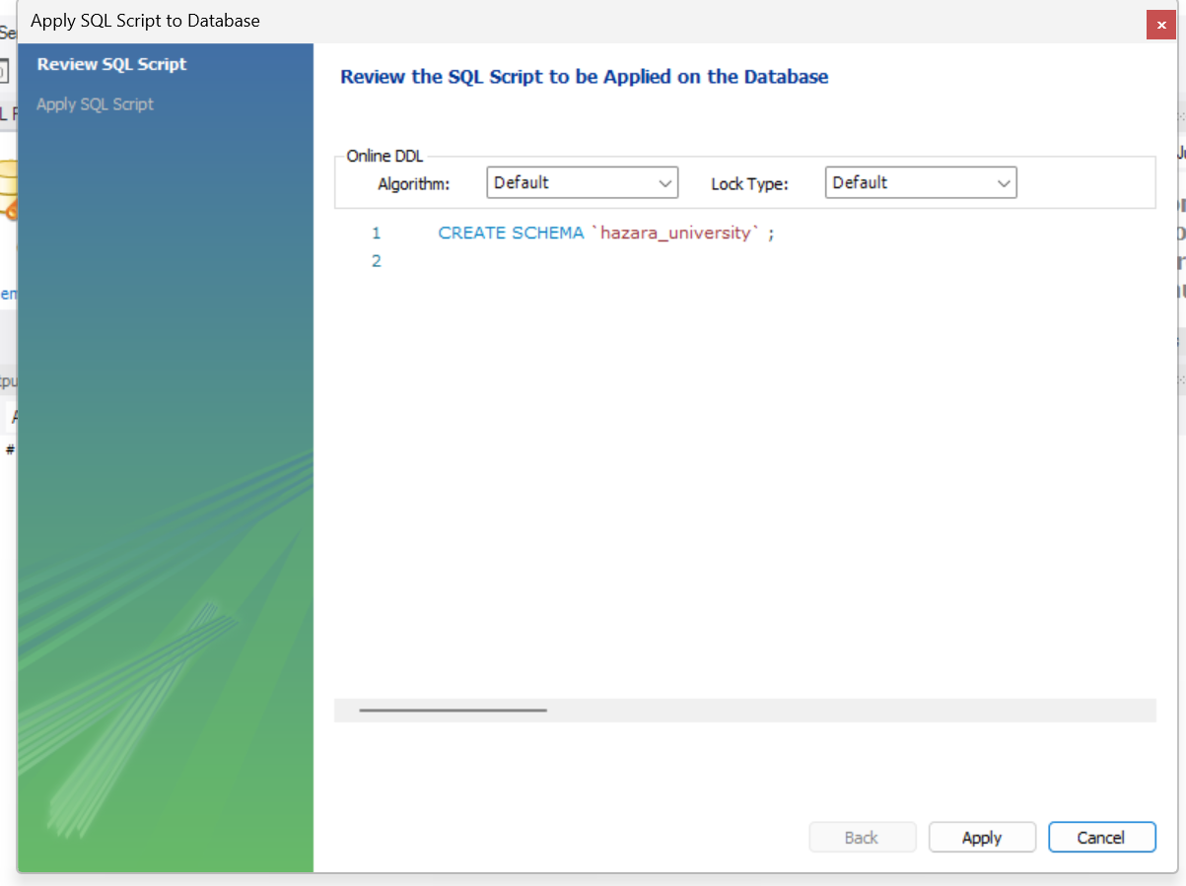

**Step 3:**

Now the database is created as shown in the left side of the tab, now for dropping I right clicked on the database name and clicked on drop schema,

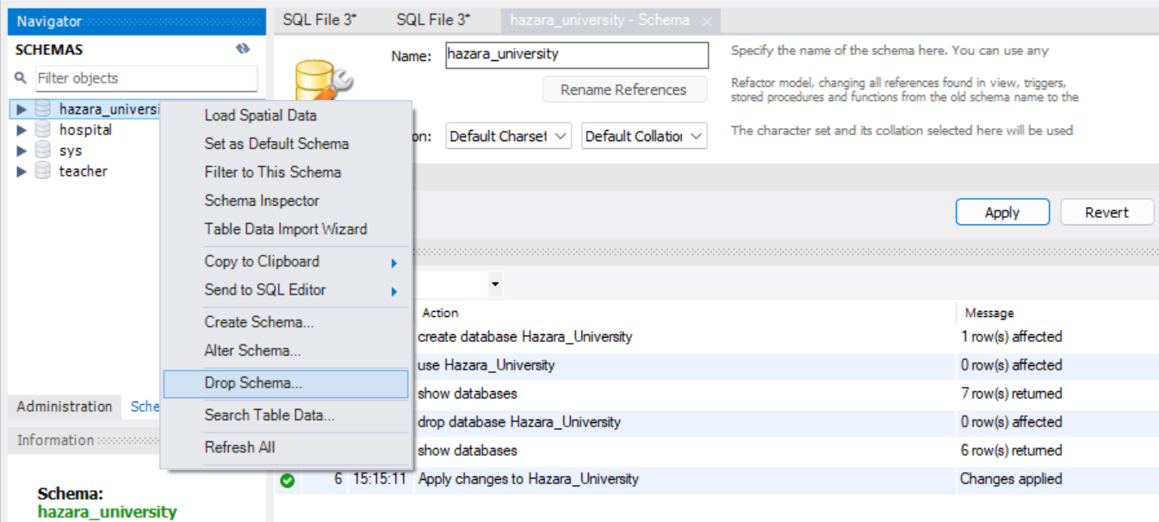

**Step 4:**

Here again I have clicked on the drop now option.

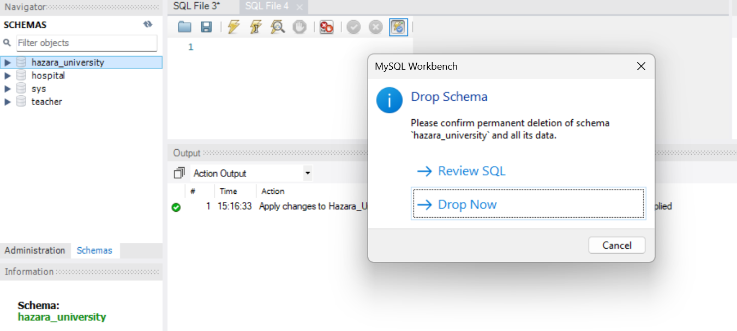

**Step 5:**

After Clicking on drop now, the database is successfully dropped from the list.

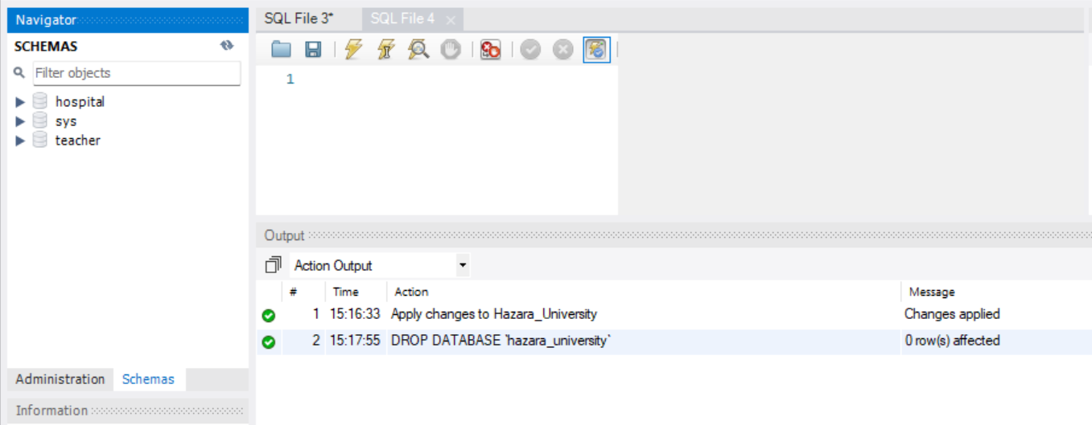

**Part 2:**

Big int, int, small int, tiny int, decimal, numeric and float (define them and tell their size)

also define date and time, their format and how much space these two take

char, varchar, text, blob ( define them too and tell the space these take)

types of constraint: not null, default, unique, primary key, foreign key, check constraint (define them too and the size they take)

part 2 mein inn sab data types ko define karna hai and yeh batana hai ky har data type kitna size leti hai (date and time ka format bhi batana hai)

**Answer:**

**Numeric Data Types**

**BIG INT:**

**Definition**:

It stores big integer values.

**Size**:

8 bytes

**INT:**

**Definition**:

This data type includes most whole numbers and is one of the most commonly used integer types.

**Size**:

4 bytes

**SMALL INT:**

**Definition**: This data type is used for smaller integer values.

**Size**: 2 bytes

**TINY INT:**

**Definition**: Used for very small integer values.

**Size**: 1 byte

**DECIMAL or NUMERIC:**

**Definition**: Stores exact numeric values, defined with a fixed number of digits, and is typically used for financial data.

**Size**: Depends on the precision, about 1 byte per digit

**FLOAT**

**Definition**: It stores approximate numeric data with a decimal point.

**Size**: 4 bytes single precision

**Date and Time Data Types**

**DATE:**

**Definition**: It stores date only from the data.

**Format**: YYYY-MM-DD

**Size**: 3 bytes

**TIME:**

**Definition**: It stores time in hour, minute, and second format.

**Display** **format**: HH:MM

**Size**: 3 bytes

**DATETIME:**

**Definition**: It will store date and time values.

**Display format:** YYYY-MM-DD HH:MM

**Size**: 8 bytes

**TIMESTAMP:**

**Definition**: This data type is used to store date as well as time, usually for modification date and time of data.

**Display format**: YYYY-MM-DD HH:MM

**Size**: 4 bytes

**String Data Types**

**CHAR(n):**

**Definition**: Character string of fixed length.

**Size**: n bytes, where n is the defined length

**VARCHAR(n):**

**Definition**: Variable-length character string.

**Size**: Takes 1 byte per character, plus 1 or 2 additional bytes for length storage

**TEXT:**

**Definition**: Variable-length string for longer text.

**Size**: Up to 65,535 characters (64 KB)

**BLOB:**

**Definition**: Binary large object for storing binary data like images.

**Size**: Up to 65,535 bytes (64 KB)

**Constraints**

**NOT NULL:**

**Definition**: Ensures that a column cannot have NULL values.

**Size**: Incur no extra storage because it enforces a constraint demanded by the database

**DEFAULT:**

**Definition**: If no value is provided for a column, then a default value will be used.

**Size**: No additional storage unless the default is stored

**UNIQUE:**

**Definition**: Ensures that all values within a column are unique.

**Size**: Negligible size for storing the index created, due to uniqueness

**PRIMARY KEY:**

**Definition**: Identifies positively each record in a table.

**Size**: The size depends on the column size and is usually minimal

**FOREIGN KEY:**

**Definition**: Constrains the establishment of the link between records in two tables.

**Size**: Generally minimal, sufficient to hold the creation of an index

**CHECK:**

**Definition**: Every value in a column must meet certain criteria.

**Size**: No extra storage needed for simple checks, complex checks may be minimally overhead.